**There are 10 print screens/code copy each worth 10%**

1. Turn to page 106 and complete Q4 the (Star Pattern) program

**#1 Print screen the output with code below here**

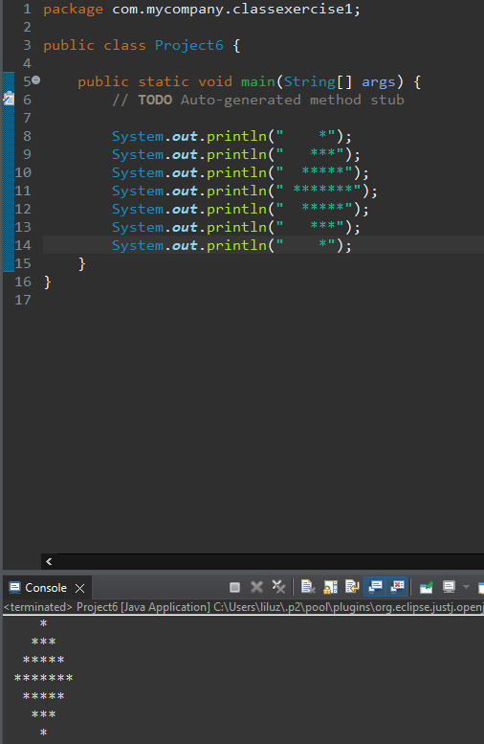

1. Turn to page 107 and complete Q10 the (Test Average) program, use a Scanner and JOptionPane class

**#2 print screen the output with code below here for the Scanner class**

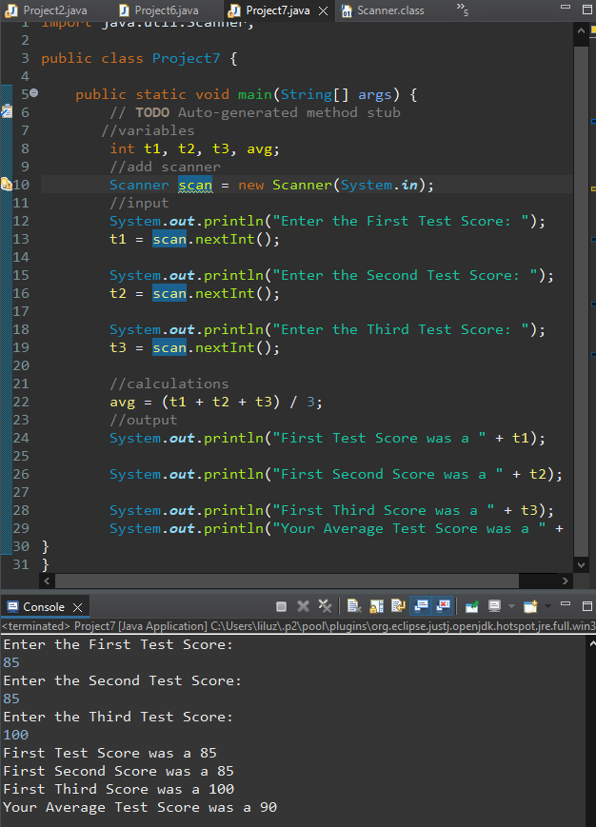

**#3 print screen the output with code below here for the JOptionPane class**

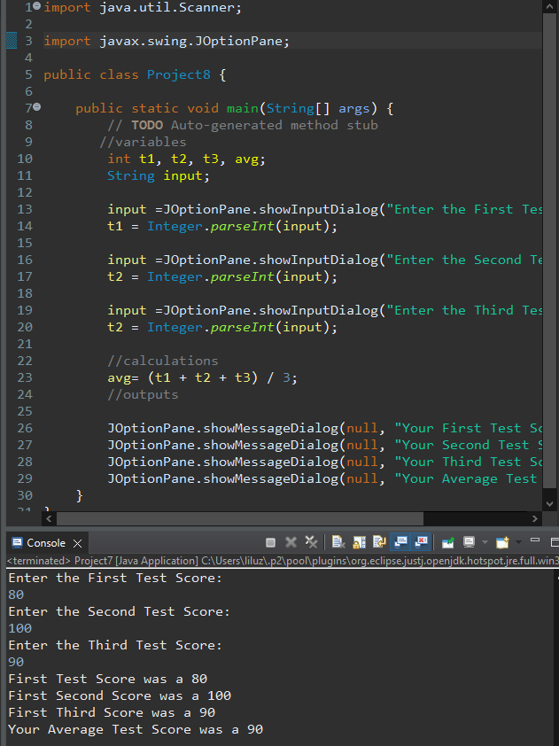

1. Turn to page 108 and complete Q15 the (Stock Commission) program

**#4 print screen the output with code below here**

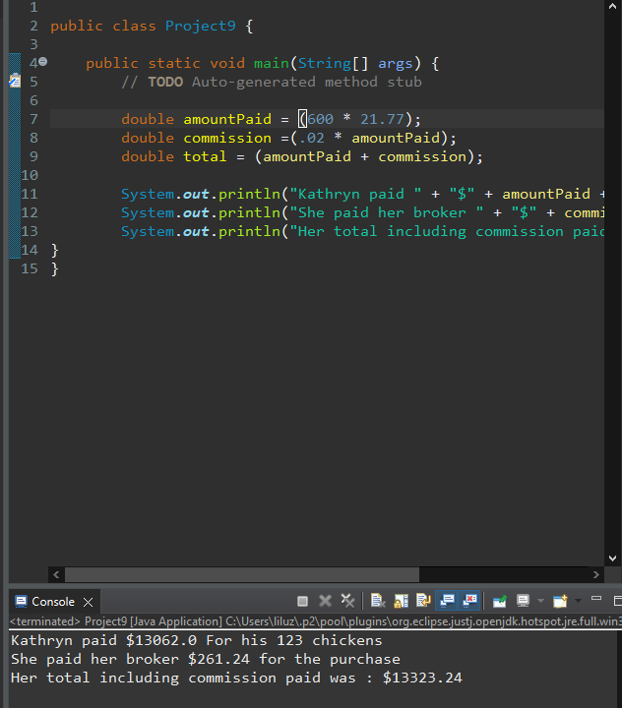

1. Turn to page 108-109 and complete Q18 the (Word Game) program

**#5 print screen the output with code below here**

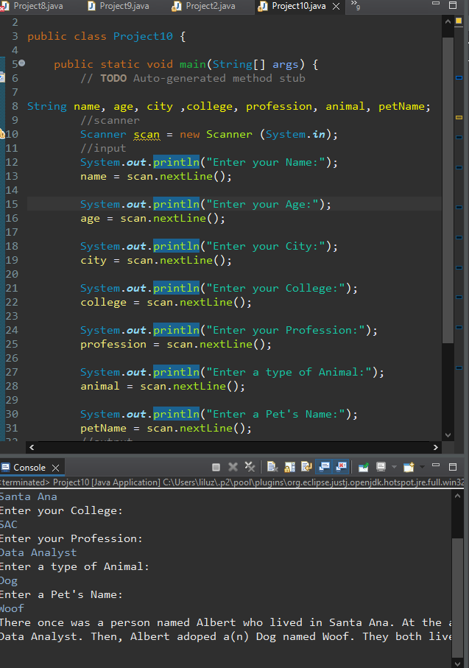

**Submit this document to Module 1 Class Exercise #1**